MGMS – Utilization Reports

Detailed Design Document

Ver. 1.4

Version History
Date | Description
14-Oct-2010 | First Draft
10-Dec-2010 | Change in calculations in Statement of Accounts

Table of Contents

Version History 2
1 Introduction 4
1.1 Purpose 4
2 Utilization certificate 4
2.1 Submit utilization certificate 4
2.2 Statement of Accounts Report 5
1.1. Statement of Accounts 6
3 Associated Tables 10

Introduction

Purpose

This document provides the detailed design specifications for the Multisite Grant Management System project.

This is not a project plan nor does it detail the source code. It is a guide for system architecture and development, not for phasing, timelines or deliverables.

Finally, this is a ‘living document’ and the specification will change, continuously, as the project proceeds. More details will be added and the existing information edited as the requirements, architecture and design evolve in the course of the project.

Utilization certificate

Submit utilization certificate

Screen & Control Description

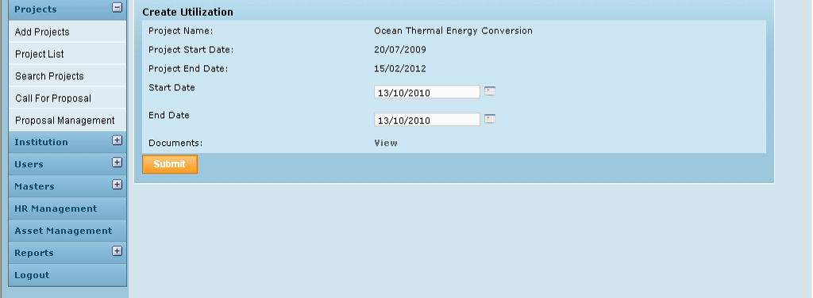

Field /Label | Input-Control | Data Type | Remarks
Create Utilization
Project Name: | Auto populated | varchar(255) | projects>name
Project Start Date: | Auto populated | datetime | projects>project_start_date
Project End Date | Auto populated | datetime | projects>project_end_date
Start Date: | Calendar | datetime | utilization>start_date
End Date: | Calendar | datetime | utilization>end_date
Documents |  |  | Link to view Utilization Certificates
View | Button |  | Opens the “Statement of Accounts Reports” window as shown below.

Statement of Accounts Report

On the screen below, on selecting the start and end date of reporting, the Statement of Accounts and the Utilization Certificate may be opened in pdf format, in 2 separate windows.
The Utilization certificate and Statement of Accounts is specific for each project running at an institution. The utilization certificate is for the year and the Statement of Account calculations are from the project’s start date to the date of generation of report.
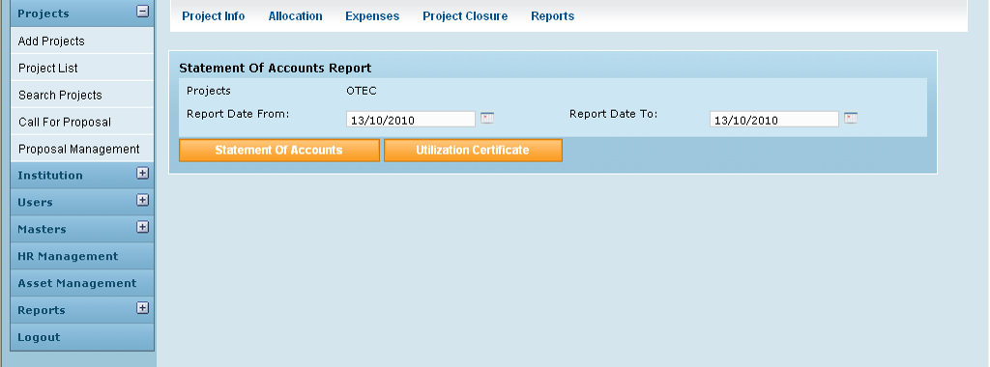

Field /Label | Input-Control | Data Type | Remarks
Statement of Accounts Report
Projects | Auto populated | varchar(255) | projects>code
Report Date From: | Calendar | datetime | Utilization period (user input)
Report Date To: | Calendar | datetime | Utilization period user input)
Statement of Accounts | Button | Opens the corresponding Statement of Accounts in pdf format, in a different window.
Utilization Certificate | Button | Opens the corresponding Utilization Certificate in pdf format in a different window.

Statement of Accounts

The report gives the cash flow in and out of the institution, for a project since its beginning till current date of generation of statement of accounts.

This includes details such as total grant allocated, amount received till now, total expenditure (account head expenses + funds transferred to other institutes as subproject allocations) and finally closing balance

Layout
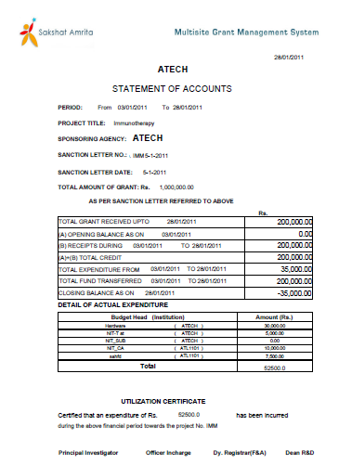

The details are given below:
1
2
3
4
5
6
7
8
9
10
11
12
14
15
16
17
13
Please refer the Functional specifications documents for the revised calculations. Funds transferred out to sub projects are not considered as expenses.

Data Source

Data Item | Format | Source
<Project Name> | varchar(255) | project>name
Period From | datetime | project>project_start_date
To | datetime | current date (date of generating report)
Project Title | varchar(255) | project>code
Sponsoring Agency | varchar(255) | party>name_of_the_institution
Sanction Letter No: | varchar(255) | grant_allocation>sanction_order_no
Sanction Letter Date | datetime | grant_allocation>date_of_allocation
Total Amount of Grant | double | sum of all values of grant_allocation>amount_allocated within the period between project_start_date and current date
 | datetime | current date
Total grant received up to <date> | double | sum of all values of grant_receipt>amount within the period between project_start_date and current date
 | datetime | project>project_start_date
(A) Opening balance as on <date> | double | Closing balance as on the date-time just before the report start date
 | datetime | project>project_start_date TO current date
(B) Receipts during <date> to <date> | double | sum of all values of grant_receipt>amount
(A) + (B) Total credit | double | sum of fields 4 & 6 above
 | datetime | project>project_start_date TO current date
Total expenditure from <date> to <date> | double | sum of fields 13 & 14 (below) i.e sum of all account head expenses and fund transfers.
 | datetime | current date
Total fund transferred |  | sum of all values of fund_transfer>amount
Closing balance as on <date> | double | Funds transferred out and expenses incurred in the institution deducted from opening balance
 | varchar(255) | account_heads>code
 | double | sum of all values of grant_expense>expense_amount for the particular account head
the row comprising of field 13 – account name and its total expense is repeated for each name of account head associated with the project
 | double | sum of all account head expenses
 | varchar(255) | project>code

Utilization Certificates

Layout & Field Description

Layout

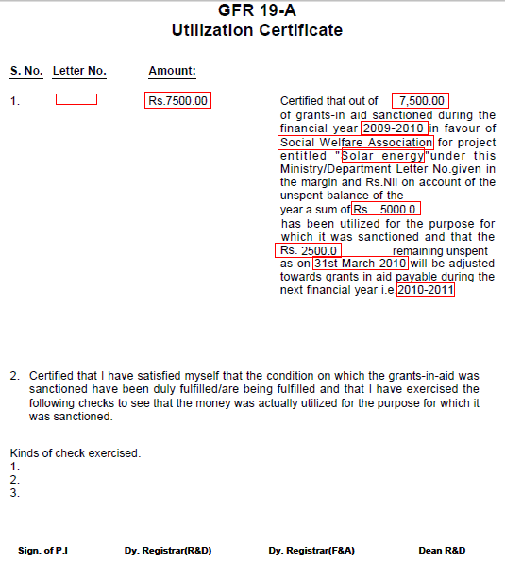
1
2
4
5
3
6
7
8
9
10

Data Source

Data Item | Format | Source
1 | varchar(255) | grant_receipt>reference_id
2 | double | sum of all values of grant_receipt>amount received with in the period of the given report start/end dates
3 | varchar(255) | party>name_of_the_institution
4 | double | sum of all values of grant_receipt>amount received with in the period of the given report start/end dates
5 | varchar(255) | grant_period>name
6 | varchar(255) | project>name
7 | double | sum of all values of grant_expense>expense_amount within the period of the given report start/end dates
8 | double | Difference between the values in fields 4 & 7 (above)
9 | datetime | last date of the current grant period
10 | varchar(255) | value of the next grant period for this project (grant_period>name)

Grouped by project name and name of the institution

Associated Tables
(next page)
